Product Main Parameter/Function

Camera | Details
Chip | CV181X
Sensor | SOI F37
Resolution | 1920×1080P
Diagonal angle of view | 161.6°
Lens focal length | 2.3mm
Night vision function | Infrared night vision
AV | Details
Video coding protocol | H.264/H.265
Video code rate | 80Kbps~800Kbps (self-adaption)
Audio compression method | G.711A/AAC
Major function | Conformity or not
3D digital noise reduction | Yes
Wide dynamic | Yes
Backlight compensation | Yes
White balance | Yes
IR-CUT | Yes
Smart | Conformity or not
Human shape detection | Yes
Motion detection | Yes
Voice detection | Yes
Forced demolition alarm | Yes
Wandering detection | Yes
Low battery alarm | Yes
Network | Description
Network Protocol | L2TP, IPv4, IGMP, ICMP, ARP, TCP, UDP, DHCP,RTP,RTSP, RTCP,UPnP, DNS,PPPoE,DDNS,NTP, FTP,HTTP, HTTPS,SIP, 802.1x
Interface | Description
Audio input and output | Audio wiring, 1 wires input, 1 wires output
Power | 5V⎓1A Charge+(built-in battery)
Button | Call button, reset button, switch button
Network interface | 2.4G WIFI
Storage | Description
Local storage | Micro SD, support a maximum of 128GB
Operation | Description
Working environment | -10℃ to +45℃

CV181X+F37 Wiring diagram
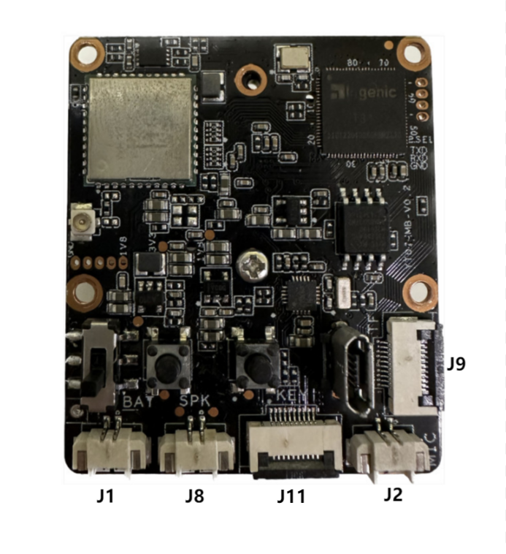
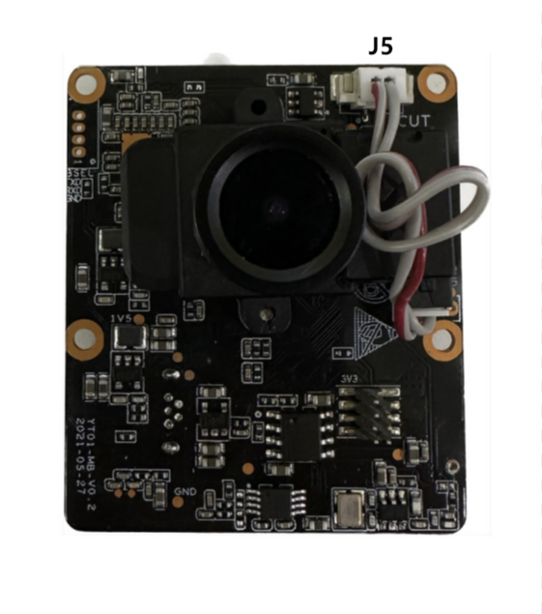

Interface | Description
J9 | 1:SC_CD 2:SC_D2 3:SC_D3 4:SC_CMD 5:V3P3_SC 6:GND  7:SC_CLK 8:GND 9:SC_D0 10:SC_D1
J2 | 1:MIC+ 2:MIC-
J11 | 1:WIFI_LED 2:CHARGE_LED 3:RING_LED 4:KEY 5:VUSB_CON  6:V3P3A 7:STDBY_LED 8:GND 9、10:NC
J8 | 1:SPK+ 2:SPK-
J1 | 1:VBAT 2:GND
J5 | 1:IR_OUTA 2:IR_OUTB

